Programming Guidelines for Functional Training
In recent years, there has been a large increase in the use of functional training equipment as part of a functional fitness training program (Thompson 2014; Thompson, 2015). Functional training has been described in the literature (functional fitness), as any exercise that replicates actual physical activities, an individual might do as a function of his/her daily routine (Osness, 1990; Rikli & Jones, 1999; Thompson, 2015). Moreover, functional training can be further defined as using any form of resistance training that improves balance, coordination, force, power and endurance to enhance someone’s ability to perform activities of daily living (Thompson, 2015). Functional training is often performed using equipment such as Kettlebells, Powerbag, Suspended Fitness Cables and Battling Ropes. Interestingly, when surveyed, a large number of the respondents said they typically utilise functional training equipment when designing fitness programs for older adults or in clinical rehabilitation programs to replicate activities performed around the home (Thompson 2015). In contrast, in high performance sporting environments, functional fitness training equipment are often utilised to enhance sports performance, as they may better replicate sporting movements and place greater demand on the bodies’ core musculature (Winwood et al. 2014). Taken as a whole, these data indicate functional training equipment appear to be utilised across a wide range of populations; to optimise activities of daily living (ADLS) and athletic performance. However, despite their widespread use in both the fitness industry and high performance sport, there is a paucity of research guiding this type of training. Therefore, the purpose of this chapter is to provide training guidelines for the use of functional training equipment in a training program designed to improve either muscle endurance, metabolic conditioning, hypertrophy, muscular strength or muscular power.

1. Training Variables
The Training variables that are common in resistance exercise prescription also apply to the development of a functional training program. These variables include: mode (ie, kettlebells, sandbags, battling ropes), intensity level (heart rate, percentage of a 1 repetition maximum), number of sets, number of repetitions per set, velocity of repetitions, and rest intervals between sets and exercises (Willardson, 2008).

2. Training Status and Frequency guidelines
Progressing a client or athlete through a functional training program safely and efficiently requires an understanding of training status that is an individual’s previous training background and exercise history. Gaining information on training status then allows the functional training instructor better understand the clients training capabilities. Information such as the type of training previously undertaken, how long this training was undertaken for, the intensity and technical lifting proficiency should all be recorded, prior to commencing a functional training program. Training frequency is then decided based on the clients current training status.
Training Classification Table.
Training status | Current length of training | Current training frequency | Current training  Intensity | Recommended training frequency
Novice | 0-6 months | 0-3 months | Low-moderate | 2-3 sessions/week
Intermediate | 8-12 months | 3-4 months | Moderate-high | 3 whole body sessions/week  or  4 split body sessions/week
Advanced | 12 months or more | 4 or more | High to very high | 4-6 whole body or split training  Sessions/week
Classification of training status, adapted from, NSCA (2015). Foundations of fitness programming.

3. Training recommendations for muscle endurance, metabolic conditioning and muscle hypertrophy
Muscle endurance is defined as the ability to continue performing submaximal muscle actions (Willardson, 2008). Whereas muscle hypertrophy involves an increase in size of skeletal muscle through a growth in size of its component cells (Haff & Triplett, 2015). Training for muscular endurance generally requires the use of higher repetitions, lower training loads and short rest periods. Such training, depending on the clients training status, may impose significant cardiovascular and metabolic stress. Functional training programs more often than not, incorporate elements of muscle endurance training, and metabolic conditioning. Metabolic conditioning is defined as any exercise or activity that imposes a moderate to high demand on the cardiovascular system and energy metabolism (Plisk, 1991). In untrained (novice) populations, circuit training has been shown to improve aerobic fitness, muscle endurance and body composition (Waller, Miller & Hannon, 2011). An important component of a circuit or metabolic conditioning program is the work to rest ratio. Plisk (1991) suggests novice clients utilise shorter work periods, and longer rest periods and as training tolerance increases, progressively increase the work periods and reduce rest periods.
Training for hypertrophy on the other hand, requires the use of moderate loads, repetitions and rest intervals; the combination these variables elicits increased muscular tension, metabolic stress and muscle damage which lead to an increase in muscle growth (Schoenfeld, 2010). Interestingly, it was previously thought that training with lighter loads was not effective in stimulating muscle hypertrophy as moderate to heavy loads with slightly longer rest periods (Schoenfeld, 2010). However, recent research has shown training with lighter loads, and higher repetitions (20+) produces similar, if not greater changes in muscle hypertrophy than previously thought (ref). This suggests that muscle endurance training protocols can also be used to stimulate muscle hypertrophy. Functional training programs looking to target improvements in muscle endurance and/or muscle hypertrophy can combine these training protocols and prescribe a combination of higher and lower repetitions, with varying loads.
Traditionally, resistance training program guidelines often utilise the percentage of one-repetition maximum (1RM) to prescribe training intensity. However, it is not practical to assess maximum lifting capabilities using functional training equipment such as; Kettlebells, sandbags, cables and battling ropes. Therefore the functional training instructor or practitioner is recommended to base training intensity on the OMNI ratings of perceived exertion (Robertson et al, 2003) rather than using the percentage of 1RM method.
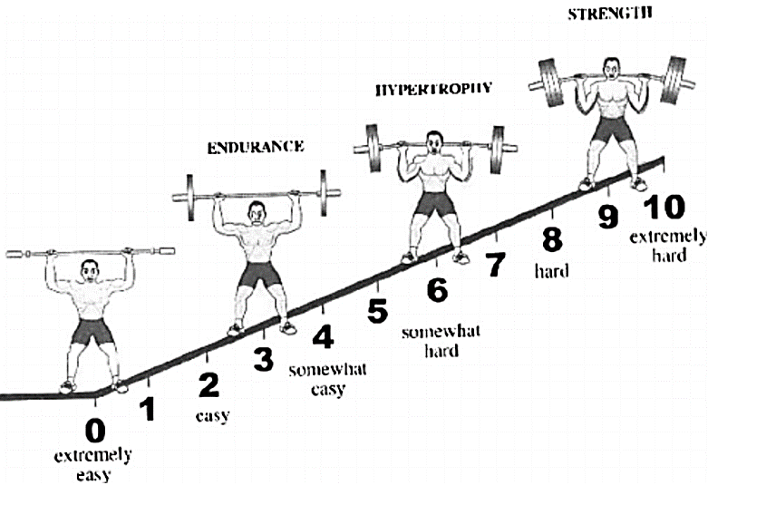
Omni resistance RPE Scale adapted from Gearhart et al. (2009).

Traditional Muscle endurance guidelines
Muscle Endurance variables | Novice | Intermediate | Advanced
sets | 1-3 | 3-4 | 3-4
Repetitions | 10-15 | 10-15 | 10-25
Rest between sets | < 30 seconds
RPE (1-10 scale) | 2-3 | 3-4 | 4-5
Description of effort/intensity | Low to moderate | Low to moderate | Low to moderate
Adapted from, NSCA (2015). Foundations of fitness programming.

Metabolic conditioning guidelines
Training Status | Work: Rest ratio | Interval time | Recovery heart rate
Novice | 1:4 | 15-30 seconds | 120 bpm
Intermediate | 1:2 | 30-60 seconds | 130 bpm
Advanced | 1:1 | 60-120 seconds | 140 bpm
Adapted from Plisk (1991).
Traditional Muscle hypertrophy guidelines
Muscle Hypertrophy variables | Novice | Intermediate | Advanced
sets | 1-3 | 3-4 | 3-4
Repetitions | 8-12 &/or  20-25 | 6-12 &/or  20-25 | 6-12 &/or  20-25
Rest between sets | 30 – 90 seconds | 30 – 90 seconds | 30 – 90 seconds
RPE (1-10 scale) | 5-6 | 6-7 | 7-8
Description of effort/intensity | Moderate | Moderate | Moderate
Adapted from, NSCA (2015). Foundations of fitness programming.
Example of a functional training metabolic conditioning program
- Kraemer & Kettlebell Training Protocol.
- Participant Demographics: Trained young males/females aged 21 years.
- Protocol: 3 x 4 minute rounds (12 minutes total), alternating between 20 seconds of work and 10 seconds of rest using the following sequence:
Exercise 1 |  | Exercise 2 |  | Exercise 3 |  | Exercise 4
Sumo deadlift | Sumo  Deadlift | Swing | Swing | Clean & press | Clean & press | Goblet squat | Goblet squat

- Estimated Intensity: 87.5% of heart rate maximum.
- Load: Males = 16k-22kg, Female 8-12kg.
- Frequency: Training frequencies for this protocol are not known, in the absence of this information, Fitness Professionals are advised to follow current recommendations for HIIT and start with one session per week, before building adding further sessions per week. Always allow 48 hours recover between sessions.
Precautions: This protocol is most appropriate for healthy younger males and females who are moderately trained. Throughout this exercise protocol, care must be taken, with client/patients lifting form and spinal alignment; especially among those with little experience. Finally, it has been suggested that clients/patients with lower fitness levels may find kettlebell training very fatiguing. If the training goal is to increase cardiorespiratory fitness, it is recommended that the kettlebell loads to commence with; be kept at approximately 13% of body mass.
Example of a functional training program for metabolic conditioning
- Ratamess et al. (2015) battling rope protocol.
 | Exercise 1 | Exercise 2
Exercise | Double-handed waves | Single-handed waves
Reps per interval | 30 | 15
Interval time | 30 seconds | 30 seconds
Rest time | Novice = 2mins Intermediate to Advanced = 1 min
rounds | 8
Total work time | 4 minutes
Total rest time | 8 minutes

Example of a Functional Training program for Hypertrophy
- Adaptation of the Morton et al (2016) protocol
Exercise | Reps | Sets | Rest interval | RPE/%1RM
Day 1 (workout A)
Sandbag squat | 20-25 | 3 | 1 minute | RPE 3-5  30-50% 1RM
Sandbag bent over row | 20-25 | 3 | 1 minute | RPE 3-5  30-50% 1RM
Sandbag overhead press | 20-25 | 3 | 1 minute | RPE 3-5  30-50% 1RM
Day 2 (workout B)
Sandbag lunges | 20-25 | 3 | 1 minute
Sandbag floor press | 20-25 | 3 | 1 minute | RPE 3-5  30-50% 1RM
Crankit bicep curl + Tricep extension super set | 20-25 | 3 | 1 minute | RPE 3-5  30-50% 1RM
Crankit abdominal roll outs. | 20-25 | 3 | 1 minute | RPE 3-5  30-50% 1RM

- Frequency: 4 – days per week (AB-OFF-AB).
- Program length: 12 weeks
- Important points: each set must be taken to “Volitional Fatigue”; once the upper limit of repetitions (25 reps) can be performed; the load should be increased by 5-10%. Conversely if the lower limit (20 reps) of the repetitions cannot be performed; the load should be reduced by 5-10%.

4. Training recommendations for maximum strength
Maximal strength is defined as the ability of the neuromuscular system to produce force against an external resistance (Stone et al. 2007). Maximal strength is often assessed via a one-repetition (1RM) maximum test, such as a 1RM bench press or back squat test. Existing maximal strength training guidelines recommend the use of heavy loads, lower repetitions and longer rest periods (Haff & Triplett, 2014; Stone et al. 2007). Training with both heavier loads and longer rest periods has been shown to have a favourable effect on both the neural and muscular systems (Moss et al. 1997). Once again, new research is also challenging these existing guidelines. For example, maximal strength has also shown to improve in response to six-weeks of higher repetition (20-25) and lower load training in experienced strength trained populations (Morton et al. 2016). Interestingly, improvements in neural adaptions often proceed muscular changes. For example, within the first two months of a training program, strength is rapidly improved in the novice lifter, primarily due to improvements in neural function. Changes in muscular properties (such as muscle size) often occur much later. However, it has been suggested that both changes are complementary to maximal strength, meaning that increasing the muscle hypertrophy (size) may promote greater increases in maximal strength. Similarly, the neural improvements that result from increasing maximum strength may assist muscle hypertrophy (Baechle et al. 2004).
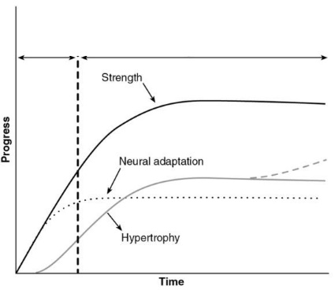
Neural and muscular adaptations to strength training over time. Adapted from Moritani and deVries (1979).
Whilst the majority of the existing guidelines for maximal strength training come from traditional strength training modalities (barbell/dumbbell) other research has shown, functional training modalities, such as training with kettlebells may be capable of achieving similar improvements in maximal strength. For instance, Lake and Lauder (2012) examined the effects of a 6-week kettlebell training program (12 sets of 30-s maximal effort kettlebell swings, alternated with 30- s rest) performed twice per week on maximum (half squat 1-RM) and explosive strength (vertical jump height) in a group of active younger males . The results showed significant improvements in both maximum and explosive strength of the participants. More recently, Otto et al. (2012) similarly reported that a 6-week periodised kettlebell training program showed significant improvements in maximum strength (1-RM squat) and explosive power in a group of recreationally active and strength trained younger males. In addition, Manocchia et al. (2013) reported 10-weeks of kettlebell training performed twice per week, in a group of moderately trained, middle-aged males and females lead to significant improvements in 3RM bench press and 3RM clean and jerk performance. The results of these studies show, in the short term, maximal strength training can be trained and improved with functional training modalities such as kettlebells. However, more research is needed to fully understand the long term effects of functional training on maximal strength. The following tables compare and contrast existing maximal strength guidelines/research for both traditional strength training and functional training.

Traditional Maximal Strength Training Guidelines
Muscle Hypertrophy variables | Novice | Intermediate | advanced
sets | 1-3 | >3 | >3
Repetitions | 6< | <6 | 6-12
Rest between sets | 2-5 mins | 2-5 mins | 2-5 mins
RPE (1-10 scale) | 8 | 9 | 9-10
Description of effort/intensity | Hard | Maximal | Maximal
Adapted from, NSCA (2015). Foundations of fitness programming.

Example of a Functional Training program for Maximal Strength
- Otto et al. (2012) Kettlebell Training Protocol
Weeks | 1-3 |  |  | 4-6
Sets x reps | 3 x 6 | 3 x 6 | 4 x 6 | 4 x 6 | 6 x 4 | 4 x 6
Exercise | KB swing | KB accelerated swing | rack squats | KB swing | KB accelerated swing | rack squats

- Load: 16 kg for males, 8 kg for females (estimated).
- Frequency: twice per week, for 6 weeks.

5. Training recommendations for power
Historically, training recommendations for power have called for a combination of ballistic strength training (medicine ball throws, jump squats, kettlebell swings) or plyometrics (box jumps, clap push ups) (Sandler 2005). The essential element for power training, is speed. If the training equipment or body part is not moved with speed, improvements in power will not be maximised. To improve power, the nervous system must improve its ability to activate as many muscle fibres as possible (Sale 1998). Training with lighter loads and fast lifting speeds drives changes in the nervous system, such as increased neural firing frequency, synergistic muscle recruitment, motor unit activation and the reduction of antagonist muscle contractions, all of which increase neural drive. These changes in neural function are all very important, because improvements in muscle power are very transferable to a vast majority of sporting movements, including sprinting and jumping, throwing and striking (Sandler 2005). 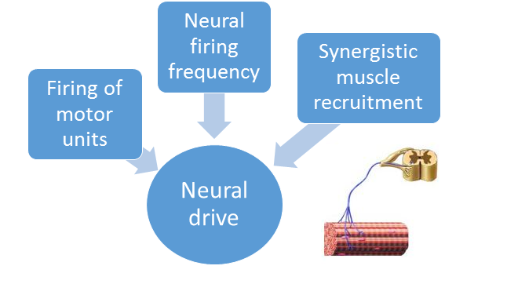
Functional training equipment such as kettlebells and Powerbags with their versatility may be well suited to power training. A growing body of research suggests functional training modalities such as kettlebell and Powerbag training may also effectively train and improve muscle power (Lake and Lauder 2012, Fathy, 2017). For example, researchers from the University of Chichester, investigated the force and power profiles of the two-handed kettlebell swing (Lake and Lauder 2012). The researchers reported peak and mean power during a kettlebell swing reach critical thresholds, known to increase in rapid force production. The authors of this study concluded that the kettlebell swing can be used as an additional exercise to develop rapid force production. These results suggest, kettlebell training can produce a transfer of strength and power to weightlifting and powerlifting exercises. In another study, researchers from Helwan University (Fathy, 2017) investigated the effects of sandbag exercises on power and shot speed in a group of female handball players. Participants completed 8-weeks of sandbag complex training. After completing the training, the hand players had significant improvements in shot speed and power, grip strength and standing long jump distance. Taken as a whole, emerging research now suggests functional training modalities such as kettlebell and Powerbag training can effectively train and enhance athletic power development.
Traditional Power Training Guidelines
Muscle Hypertrophy variables | Novice | Intermediate | advanced
sets | Not recommended. | 1-3 | >3
Repetitions |  | 3-6 | 6-12
Rest between sets |  | 2-5 mins | 2-5 mins
RPE (1-10 scale) |  | 3-6 | 4-7
Description of effort/intensity |  | Moderate | Moderate
Adapted from, NSCA (2015). Foundations of fitness programming.
Example of a Functional Training program for power
- Lake and Lauder (2012) Kettlebell training Protocol.
 | Exercise
Exercise | Kettlebell Swings
Interval time | 30 Seconds
Rest time | 30 Seconds
rounds | 12
Total work time | 6 minutes
Total rest time | 6 minutes

- Load: Males with a body mass > 70kg = 16kg, <70kg =12kg. Female’s weight estimated between 4-8kgs.
- Frequency: twice per week, for 6 weeks.

Summary and conclusion
As with any training method, it is important for fitness trainers to adhere to standard exercise guidelines to ensure client safety and to maximise their time and effort when using functional training equipment. A summary of these guidelines include (adapted from Coburn & Malek, 2012):
- For safety purposes, ensure that all functional training equipment is checked prior to use.
- As per the Fitness Australia “Safety Guidelines for Strength Training”, exercise selection must be suited to the movement capacity of the individual.
- As with other modes of training, a warm up session of 5 to 15 minutes should precede the actual workout.
- Allow sufficient time for the client to become familiar with the functional training equipment. For example, it is not uncommon for a client to demonstrate good strength levels in traditional types of equipment; but have difficulties matching this strength when using functional training equipment. This is particularly true, when clients are initially transitioned off machine based training to free weight or functional training. Machine based training does not activate stabilising muscles to the same degree as functional training, therefore when the client commences functional training, their stabiliser muscles will fatigue rapidly, which will decrease exercise technique. In such instances, the trainer must stop the exercise at the point that exercise technique deteriorates.
- Select the most appropriate loading scheme. The number of sets, reps and amount of load should be selected on the training age and fitness level of the client.
- Ensure proper attention is paid to client recovery; following a functional training session clients should cool down for 5 to 10 minutes including muscle recovery activities (foam roller, stretching etc).

In conclusion, the information included in this chapter demonstrates how functional training equipment can be incorporated into training programs to improve specific parameter such as muscle endurance, metabolic conditioning, hypertrophy, muscular strength and muscular power. Additionally, due to their unconventional design, functional training equipment can replicate many activities of daily living and sport specific movements; that traditional resistance training equipment cannot replicate. Clients who commence functional training often report improved enjoyment due to the challenge, skill acquisition and variety, which may ultimately lead to improved adherence and retention to a fitness training program.

References:

Baechle, T. R., Earle, R. W., & Baechle, T. R. (2004). NSCA's essentials of personal training. Human Kinetics.
Brown, K. (2009). The Bulgarian Bag: Extreme Training for the Next Fitness Generation. NCSA's Performance Training Journal, 8, 11-12.
Burd, N. A., West, D. W., Staples, A. W., Atherton, P. J., Baker, J. M., Moore, D. R., ... & Phillips, S. M. (2010). Low-load high volume resistance exercise stimulates muscle protein synthesis more than high-load low volume resistance exercise in young men. PloS one, 5(8), e12033.
Clayton, N, Drake, J, Larkin, S, Linkul, R, Martino, M, Nutting, M, and Tumminello, N. Foundations of Fitness Programming. National Strength and Conditioning Association, 2015
Coburn, J. W., & Malek, M. H. National Strength and Conditioning Association (US).(2012). NSCA’s Essentials of Personal Training.
Gearhart Jr, R. F., Lagally, K. M., Riechman, S. E., Andrews, R. D., & Robertson, R. J. (2009). Strength tracking using the OMNI resistance exercise scale in older men and women. The Journal of Strength & Conditioning Research, 23(3), 1011-1015.
Haff, G., & Triplett, N. T. (2015). Essentials of strength training and conditioning.
Häkkinen, K. (1989). Neuromuscular and hormonal adaptations during strength and power training. A review. The Journal of sports medicine and physical fitness, 29(1), 9-26.
Lake JP and Lauder MA. (2012). Kettlebell swing training improves maximal and explosive strength. J Strength Cond Res. 26:2228-2233.
Morton, R. W., Oikawa, S. Y., Wavell, C. G., Mazara, N., McGlory, C., Quadrilatero, J., & Phillips, S. M. (2016). Neither load nor systemic hormones determine resistance training-mediated hypertrophy or strength gains in resistance-trained young men. Journal of Applied Physiology, 121(1), 129-138.
Moss, B. M., Refsnes, P. E., Abildgaard, A., Nicolaysen, K., & Jensen, J. (1997). Effects of maximal effort strength training with different loads on dynamic strength, cross-sectional area, load-power and load-velocity relationships. European journal of applied physiology and occupational physiology, 75(3), 193-199.
Moritani and DeVries (1979). "Neural factors versus hypertrophy in the time course of muscle strength gain, American Journal of Physical Medicine 58(3):115-130
Otto WH, Coburn JW, Brown LE, and Spiering BA. (2012). Effects of weightlifting vs. kettlebell training on vertical jump, strength, and body composition. Journal of Strength Conditioning Research. 26: 1199-1202.
Osness, W. H. (1990). Functional Fitness Assessment for Adults Over 60 Years (A Field Based Assessment). AAHPERD Publication Sales Office, 1900 Association Drive, Reston, VA 22091.
Plisk, S. S. (1991). Anaerobic metabolic conditioning: a brief review of theory, strategy and practical application. Journal of Applied Sport Science Research, 5(1), 22-34.
Ratamess, N. A., Rosenberg, J. G., Klei, S., Dougherty, B. M., Kang, J., Smith, C. R. & Faigenbaum, A. D. (2015). Comparison of the acute metabolic responses to traditional resistance, body-weight, and battling rope exercises. The Journal of Strength & Conditioning Research, 29(1), 47-57.
Reuter, B. & Hagerman, P.S. (2008). Aerobic Endurance Exercise Training. In Baechle & Earle, Essentials of Strength and Conditioning (pp. 489-503). Champaign, IL: Human Kinetics.
Rikli, R. E., & Jones, C. J. (1999). Development and validation of a functional fitness test for community-residing older adults. Journal of aging and physical activity, 7(2), 129-161.
Robertson, R. J., Goss, F. L., Rutkowski, J., Lenz, B., Dixon, C., Timmer, J., & Andreacci, J. (2003). Concurrent validation of the OMNI perceived exertion scale for resistance exercise. Medicine & Science in Sports & Exercise, 35(2), 333-341.
Sandler, D. (2005). Sports power. Human kinetics.
Sale, D. G. (1988). Neural adaptation to resistance training. Medicine and science in sports and exercise, 20(5 Suppl), S135-45.
Schoenfeld, B. J. (2010). The mechanisms of muscle hypertrophy and their application to resistance training. The Journal of Strength & Conditioning Research, 24(10), 2857-2872.
Stone, M. H., Stone, M., & Sands, W. A. (2007). Principles and practice of resistance training. Human Kinetics.
- Thompson, W. R. (2013). Now trending: worldwide survey of fitness trends for 2014. ACSM Health Fitness J, 17(6), 10-20.
- Thompson, W. R. (2014). Worldwide survey of fitness trends for 2015: what’s driving the market. ACSM's Health & Fitness Journal, 18(6), 8-17.
- Waller, M., Miller, J., & Hannon, J. (2011). Resistance circuit training: Its application for the adult population. Strength & Conditioning Journal, 33(1), 16-22.
- Willardson, J. M., Emmett, J., Oliver, J. A., & Bressel, E. (2008). Effect of Short-Term Failure versus Nonfailure Training on Lower Bod Muscular Endurance. International journal of sports physiology and performance, 3(3), 279-293.
- Winwood, P. W., Cronin, J. B., Keogh, J., Dudson, M., & Gill, N. (2014). How coaches use strongman equipment in strength and conditioning practice. Retrieved from http://dx.doi.org/10.1260/1747-9541.9.5.1107.

