What We Say Matters
by Nick Winkelman
an NSCA Hot Topic
An introduction to aspects of coaching science that impact the effectiveness of strength and conditioning professionals. In Part I, learn how instruction primes the motor system by providing contextual understanding of the movement skill.

Part I

IntroductionIf 10 identical twins were trained by 10 different coaches following the same training plan (methods) and all variables were controlled, would we see the same results? The simple answer would be “yes” and the assumption would be that training methods are the primary factor driving the trainee’s success. The difficult answer would be “no” and the assumption would be that training methods are limited by the person coaching them.
Answering "yes" would support the current emphasis across strength and conditioning literature on training methods and mechanisms, but answering "no" would expose a deficit in the literature pertaining to the applied coaching sciences directed at the strength and conditioning professional.
While this paper does not seek to provide a final answer to the posed question, it does seek to address a deficit within the strength and conditioning literature, and present a foundation for understanding the science of coaching.
The purpose of this paper is to provide an introduction to aspects of coaching science that will directly impact the effectiveness of strength and conditioning professionals. While coaching is multifaceted, the ability to teach is a “red thread” across great coaches.
John Wooden once said that “you haven’t taught until they have learned” (6), and through this quote we see that learning is a function of effective teaching. The science of coaching literature provides over 30 years of research pertaining to teaching practices and the optimal use of instruction and feedback.
The following sections will discuss the underlying mechanisms and recommended application across effective instruction and feedback. Within the paper the author presents the following arguments (Part I) instruction primes the motor system by providing contextual understanding of the movement skill and (Part II) feedback refines the motor system by guiding the athlete towards a movement pattern in a manner that promotes implicit (self-correcting) processes.
Science of InstructionInstructing athletes on how to perform on-field movement skills (e.g., sprinting) and primary strength movements (e.g., Olympic-style lifts) in the weight room are fundamental coaching responsibilities. Instruction can be considered information given prior to a skill in an effort to guide the athlete towards an efficient movement pattern.
The goal of instruction is to prime the motor system by providing contextual understanding of the movement skill being learned. It should be noted that contextual understanding refers to the athlete’s ability to understand how to perform and self-correct a movement skill without feedback from a coach.
Instruction can be broken into two primary components that include visual and verbal instruction (see Figure 1). Visual instruction or movement demonstration is further broken down into an athlete observing a novice or expert demonstration prior to performing the movement themselves.
Verbal instruction can be broken into internal versus external cues, which focus the athlete on different elements of the movement being learned. The following section will examine the effectiveness of visual and verbal instruction and their component parts.
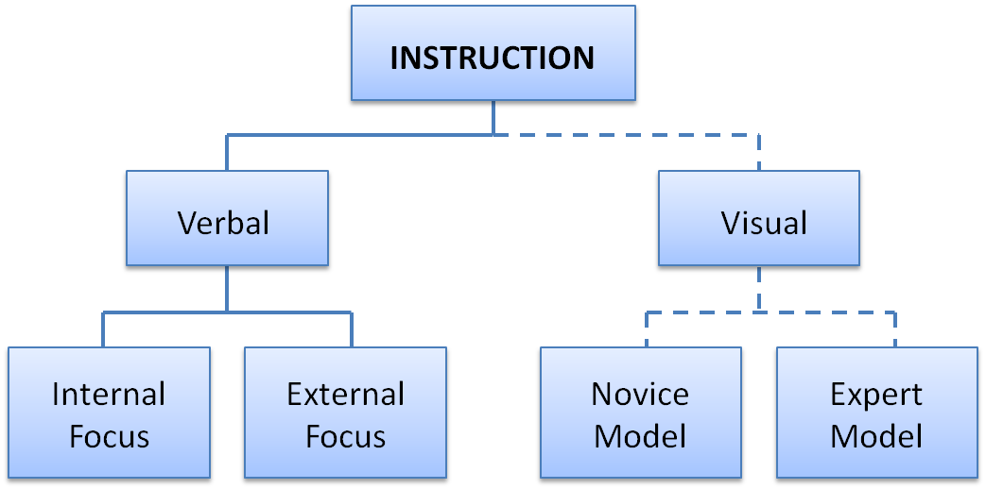
Figure 1. Instruction Model
Visual Instruction (Demonstration)Coaches will make an effort to master movement skills for the purpose of expert demonstration or have an athlete demonstrate the movement if the coach is unable to. Research has shown there is a benefit from observing both novice and expert demonstration (1). Shoenfelder-Zhodi (9) showed that observing an expert model compared to verbal instruction resulted in earlier acquisition of a ski simulator task.
While observing expert demonstration improves learning, there is a vast amount of evidence supporting the observation of novice models for improved learning (2, 4, 5).
Observing a novice model may call attention to errors, promoting problem-solving and the discovery of appropriate movement patterns through implicit learning (1, 3). From a practical standpoint it can be recommended that a combination of expert and novice observation will allow for an enriched learning environment.
Expert models can be used in the initial instruction and novice models are used by calling athlete’s attention to one another during practice. The use of “waterfall starts” and “partner coaching” will allow for a balance of expert and novice observation. Below is an example of using waterfall starts and partner coaching:
Waterfall Starts (Harness Acceleration Sprints): 10 athletes in harnesses stand across a line with a partner athlete holding the harness leash allowing them to hold a 45º acceleration angle. Athletes are instructed to sprint (accelerate) over a 15-yard distance building intensity. The waterfall start dictates that the far athlete goes first and once they have passed 5 yards the next athlete will go with the pattern continuing until all 10 athletes have sprinted. This will allow athletes to observe a range of movement abilities and provides the coach with a more controlled environment to direct feedback (see next section).
Partner Coaching (Weightlifting): Athletes are partnered in groups of two to three per platform and instructed to watch one another during the training session. Athletes will naturally identify errors in their fellow athlete’s technique and start coaching one another. This drives group cohesiveness and partner coaching which scales the coach’s capabilities.
Verbal InstructionVerbal instruction can focus an athlete internally on body movements or externally on the result of the movement (11, 12, 14, 16, 17). For example, telling an athlete to “rapidly extend your legs” during an acceleration sprint would constitute an internal cue and “drive the ground away” would be an example of an external cue. The concept of internal versus external cuing or attentional focus was first seen through the work of Wulf et al. (14).

This critical study involved two experiments of similar demand. Experiment 1 looked at the effect of internal versus external focus when using a ski-simulator. The internal focus group was “instructed to exert force on the outer foot” and the external focus group was “instructed to exert force on the outer wheels,” while the control group received no instruction.

This subtle difference in focus resulted in statistically greater improvement during practice and retention for the external compared to the internal focused group. It should be noted that retention refers to testing in the absence of instruction and feedback after a given time period has elapsed (e.g., 24-48hrs).
Experiment 2 looked at internal versus external focus as it relates to a balance task. The internal focus group was asked to keep their feet at the same height while the external focus group was asked to keep the red lines in front of their feet at the same height. The results were similar to Experiment 1 with the external focus group having significantly less errors during the retention test.
Since this study there has been extensive research validating the efficacy of external focus across vertical jumping (12, 13), long jump (8), agility (7), soccer and tennis (16), and golf (15, 19). Further work has shown that external focus is not only important for the novice learner, but has also shown efficacy in expert acrobats (10) and golfers (19).
Table 1 provides examples of internal versus external focus cues for different movements and note that analogies can be considered external cues.
 | Internal Cue | External Cue
Sprinting: Acceleration | - Extend your hip (knee)  - Activate your quad (glute)  - Stomach tight | - Drive the ground away  - Explode off the ground  - Brace up
Change of Direction | - Hips down  - Feet wide  - Drive through big toe | - Roof over head  - Train tracks or wide base  - Push the ground away
Jumping | - Explode through hips  - Snap through ankles  - Drive hips through head | - Touch the sky  - Snap the ground away  - Drive belt buckle up
Olympic Lifting: Snatch | - Drive feet through ground  - Drive chest to ceiling  - Snap hips through the bar  - Drive feet through ground  - Drive chest to ceiling  - Snap hips through the bar | - Push the ground away  - Drive/jump vertical  - Snap bar to ceiling  - Snap and drop under bar
Table 1. Examples of Internal vs. External Focus Cues for Various Movement Skills
While it has been well-established that an external focus of attention is superior to an internal focus there is less known about the underlying mechanisms. The constrained action hypothesis (CAH) has been suggested as a theoretical explanation for the benefits of adopting an external focus of attention (11, 17, 18).
Wulf et al. (17) defined the hypothesis, stating that focusing on body movements (i.e. internal) increases consciousness and “constrains the motor system by interfering with automatic motor control process that would ‘normally’ regulate the movement,” and therefore by focusing on the movement outcome (i.e., external) allows the “motor system to more naturally self-organize, unconstrained by the interference caused by conscious control attempts.”
To test this hypothesis, research was done to evaluate if an external focus of attention actually increases automatic processing during a task. Wulf et al. (17) looked at reaction time during a balance task and found that an external focus decreased balance error and reaction time compared to an internal focus during a retention test.
This further supports the notion that adopting an external focus can improve learning and performance as a function of automatic processes. In sum, an external focus compared to internal focus reduces consciousness and therefore the amount of attention needed to perform a given task. This frees up attentional resources that can be used to further the efficiency and automaticity of a movement skill.
Applied Implications
From an applied standpoint, the use of visual and verbal instruction can be recommended. Visual instruction creates an image in the athlete’s mind and the verbal instruction drives the outcome of what the image represents. Instruction will continue to be important as new and more complex skills are taught, but can be minimized as previously learned skills are repeated.
The amount of information should be kept at a minimum within an external focus and prioritized towards critical elements of the movement skill being taught.
Part II of this article will discuss the underlying mechanisms and application of feedback. Final conclusions are also presented in Part II, discussing the application of instruction and feedback across the learning continuum.

What We Say Matters, Part II
by Nick Winkelman
and NSCA Hot Topic
An introduction to aspects of coaching science that impact the effectiveness of strength and conditioning professionals. In Part II, learn how feedback refines the motor system by guiding the athlete towards a movement pattern in a manner that promotes implicit (self-correcting) processes.
Once a movement skill is performed it is appropriate for the coach to provide feedback to the athlete. Feedback refines the motor system by guiding the athlete towards a movement pattern in a manner that promotes implicit (self-correcting) processes. Feedback is classically broken down into two categories comprised of task-intrinsic feedback (TIF) and augmented feedback (AF) (Figure 2) (10).

TIF is considered information that is obvious to the athlete and is received across visual, auditory, tactile, and proprioceptive sensory inputs. Providing feedback on information that is apparent to the athlete can be considered redundant and therefore can be avoided (11). We know that working memory and attention are limited in capacity (13) and for this reason it is critical that we limit information to what is necessary for the athlete’s success.

AF on the other hand provides information to the athlete that is not currently known and can be broken down into the following categories:
  - Knowledge of Results (KR): Information about the outcome of a movement task or if a goal was achieved (e.g. 40 yard sprint time or ball location on the golf fairway for a dogleg left shot)
  - Knowledge of Performance (KP): Information about the movement qualities that led to the performance outcome (e.g. “you came up to quickly out of your 3pt stance” or “you were to early on your second pull during the snatch”)
The following section will discuss the application of AF as it relates to feedback timing, frequency, content, and methods.
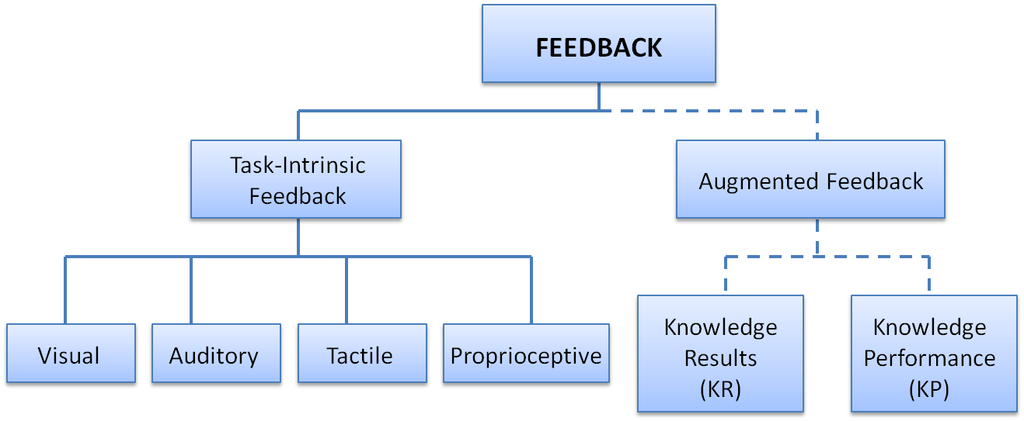
Figure 2. Feedback Model

Feedback Timing
Feedback timing is broken into two categories where concurrent feedback is given during the task and terminal feedback is given after the task. While there is limited research in the area of concurrent feedback the majority of research has shown that concurrent feedback may have a negative affect on retention and transfer of movement skills (14, 16, 20).

Providing feedback during a movement becomes a distraction that increases conscious thought and can take away from movement efficiency and implicit learning. Research on concurrent feedback has shown potential benefits for the use of mirrors in novice athletes learning a weightlifting skill (18) and auditory feedback used during a repetitive gymnastic skill (2).

Concurrent feedback from mirrors may help the athlete identify with the feeling of certain positions that are critical to the movement being taught (e.g. Weightlifting). This positional awareness and increase in kinesthetic sense will help them self-correct when mirrors are no longer available.

Concurrent auditory feedback may have strong application within coaching repetitive movement skills. Many speed development drills are dependent on specific rhythm and tempos. A case can be made that auditory cadences can be used during various skipping patterns, acceleration and absolute speed sprint drills.

For example, it is common for a novice sprinter to use excessive stride frequency during the acceleration portion of a 40yd sprint. A coach may use specific auditory cues such as “push, push, push” to match the desired frequency of the first three contacts out of a start stance. A case can be made that this generates a context for the cadence of the movement skill, but does not disrupt learning by providing detailed information about the pattern itself (i.e. internal cueing).
Feedback Frequency
Terminal feedback is provided after a movement skill is performed and has been well established within the literature (9). What has come into question is the frequency with which KR and KP should be given to the athlete. Logic would say that the more feedback we receive during practice the better the learning effect, but in adopting this absolute view we would find our logic to be flawed. Winstein and Schmidt (21) examined the difference between providing feedback on 100% versus 50% of trials while subjects learned a novel movement pattern.

Across three experiments they found that providing feedback on 50% of trials was superior to 100% of trials. Meaning that the initial trials would have received 100% feedback and later trials may only receive 33% feedback with the total feedback across practice being 50% of total trials. Over the last two decades research has continued to support the notion that feedback should not be given on 100% of trials (1, 12, 14, 17, 25).

In support of the conclusion that a reduction in terminal feedback improves retention and transfer of learning Salmoni and colleagues (15) proposed the guidance hypothesis, stating that feedback guides learning during skill acquisition, but if given too often can create “feedback dependency” resulting in decreased performance when the feedback is removed (10, 22).

We see this hypothesis realized frequently within a sport context. An athlete is exposed to a coach that provides frequent feedback with good intentions. The athlete is able to practice very well and develops a need for feedback on every repetition. The problem arises when that athlete has to perform in competition and no longer has access to immediate feedback. To generate success in sport we must use feedback frequencies that improve an athlete’s ability to implicitly self-correct in an effort to move them towards higher levels of automatic processing.

As coaches we must realize that what we say is as important as what we don’t say and as an athlete progresses it is critical that we allow them to make mistakes and problem-solve.
Feedback Content
While researches collectively agree with the guidance hypothesis, there is research to show that it is not only the frequency with which feedback is given, but also the content of the feedback. Wulf et al. (24) looked at internal versus external focus under 33% and 100% feedback frequencies for a soccer passing accuracy test. Results were significant and found that an external focus with 33% and 100% feedback resulted in superior accuracy compared to both internal conditions during practice and retention.

What should be noted is that accuracy was significantly higher during the 33% internal condition compared to the 100% internal condition. The results of this study are important as the authors showed that 100% feedback can be given when the message is an external focus, but in the case of an internal focus the guidance hypothesis is in effect and feedback frequency should be reduced. Recent work by Wulf and colleagues (23) continues to reinforce that feedback frequencies should be evaluated as a function of the feedback content.
From an applied standpoint we know that coaches will typically cue movement positions and movement patterns. Our current knowledge would say that we should use external focus cues when providing feedback on the dynamics of the movement pattern, but less is known about cuing movement positions. From a squatting standpoint coaches will typically cue “chest up”, “hips back”, “core tight”, “weight on the heels”, etc. By our definition all of these cues would be internal and based on the research presented we would have to challenge their efficacy.

The author’s belief is that while external focus cues should be directed at the movement pattern, internal or external focus cues can be used for movement positions. The reasoning is that these are set-up cues which should not disrupt the dynamics of the movement pattern being performed.
Feedback Methods
In an effort to decrease feedback frequency various feedback methods have been proposed for use in applied settings. The following feedback methods are represented in the literature and have applied merit (10):
  - Bandwidth Feedback: Feedback is given when a performance error exceeds a pre-determined range. Performance errors can relate to qualitative performance (e.g. movement pattern) or quantitative results (e.g. movement time). (Example: A coach will only give feedback during a sprint when time drops below a 10% bandwidth or a coach will only give feedback when a specific error is seen during the power snatch) (19).
  - Summary Feedback: Feedback is given after a series of trials (i.e. <100% feedback frequency) and a summary of KR or KP from every trial is provided. This method decreases feedback frequency, but still delivers the same amount of information as 100% feedback frequency. (Example: An athlete would perform 3-5 repetitions of a movement and then the coach would provide feedback in reference to each repetition) (17, 21, 26).
  - Average Feedback: Feedback is given after a series of trials and average KR or KP across trials is provided. This method decreases feedback frequency and provides feedback on the average performance errors or results across trials performed. (Example: An athlete would perform 3-5 repetitions of a movement and then the coach would provide feedback on the most common error seen over the repetitions) (17, 21, 26).
  - Fading Feedback: Feedback is given at higher frequencies at the beginning of a skill acquisition session (i.e. 100%) and fades as the session progresses (i.e. 33%). This fading can happen across trials within a session or across multiple sessions. (Example: Coach might give feedback on every repetition during sets 1-5 of a weightlifting session, feedback on 50% of repetitions for sets 6-10, and feedback on 33% of the repetitions for sets 11-15) (21).
  - Self-Selected Feedback: Feedback is given at the request of the learner in response to their perception of a bad trial, a good trial, or when they are unsure (Example: Coach would preface the session telling the athletes that feedback will only be provided at the request of the athlete) (3-8).
Conclusion
This paper proposed underlying mechanisms and application in relation to instruction and feedback as critical components within the science of coaching. These methods were highlighted as potential limiting factors in the effective delivery of training methods from coach to athlete.
Table 2 provides a framework for applying instruction and feedback. From an instruction standpoint expert demonstration should be used during initial learning. As the athlete improves their ability to identify environmental cues and self-correct, the use of novice demonstration will improve problem solving capabilities. Within the instruction model the use of verbal instruction should focus on up-regulating the use of external focus cues and analogies while decreasing internal cueing. Feedback should be provided terminally unless concurrent feedback is used to support cadence.

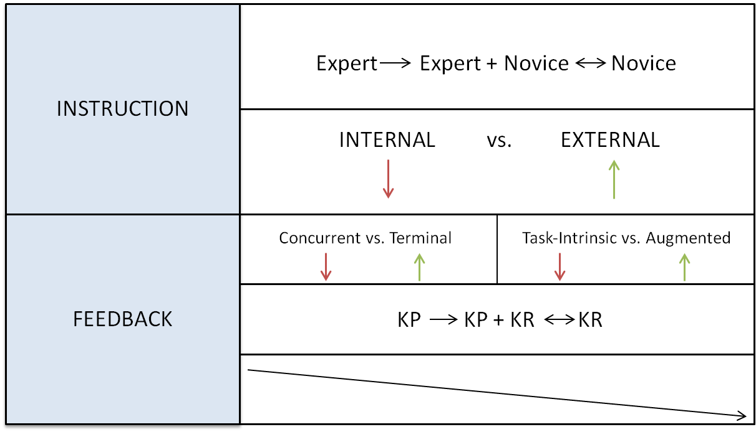
Table 2. Instruction and Feedback Framework

Task-intrinsic information that is redundant should be avoided and therefore augmented feedback should focus on KR and KP that is unknown to the athlete. During initial learning feedback should primarily focus on KP as this will improve the athlete’s knowledge of how to perform and improve a movement skill. As the athlete moves towards automatic processing they can readily self-correct their movement performance and will depend on KR as the primary feedback form. Within the delivery of feedback the message should be focused on top priority corrections and delivered with an external focus.

Despite research showing that external focus feedback can be given 100% of the time there is still strong evidence to show that feedback frequency should decrease from 100% to 33-50% of absolute repetitions as the athlete moves towards automatic processing.

All of these recommendations come with the understanding that to reach the highest level of sport an athlete must be able to express their skill in complex environments, with high levels of autonomy, and minimal coach interaction. Therefore our coaching must evolve to provide instruction and feedback methods that hand “the keys to the car” over to the athlete and allow them to own their skill. While this is difficult for coaches, it comes with the understanding that knowing when to communicate is as important as knowing when not to.

In summary, the science of coaching provides coaches with critical insights on how to optimize the delivery of information to maximize the effect of the training methods used. While this paper was not an exhaustive review of all components within coaching science, it will provide coaches with critical insights that can have an immediate affect on their athlete’s performance.

